Excel Assignment – 17

1. What are modules in VBA and describe in detail the importance of
creating a module?

Modules in VBA are containers within a workbook that store VBA code, such as macros and functions. They are part of the Project Explorer in the VBA Editor.
Importance of Creating Modules:
- Organization: Keeps code structured and separate for better readability.
- Reusability: Allows code to be reused across different parts of the project.
- Debugging: Easier to locate and fix issues when code is organized in modules.
- Modularity: Helps break complex tasks into smaller, manageable chunks.
How to Create a Module:
- Open the VBA Editor (Alt + F11).
- Right-click the project in Project Explorer > Insert > Module.

2. What is Class Module and what is the difference between a Class
Module and a Module?

A Class Module in VBA is used to create custom objects with properties, methods, and events, enabling object-oriented programming in VBA.
Difference Between a Class Module and a Module:

Feature | Module | Class Module
Purpose | Stores macros, functions, and code for procedures. | Creates custom objects with encapsulated properties and methods.
Usage | Procedural programming. | Object-oriented programming.
Scope | Code is accessible globally. | Requires an object instance to access.
Encapsulation | No encapsulation of data. | Encapsulates data and behaviors in an object.

Example:
- Module: Subroutines like CalculateSum().
- Class Module: Defines an object like Car with properties Color and Speed.

3. What are Procedures? What is a Function Procedure and a Property
Procedure?

Function Procedure:
- A procedure that returns a value.
- Used for calculations or tasks where a result is needed.
- Example:

Function AddNumbers(a As Integer, b As Integer) As Integer
AddNumbers = a + b
End Function

Property Procedure:
- Used in Class Modules to define properties of objects.
- Includes Property Get (retrieve value), Property Let (set value), and Property Set (set object references).
- Example:
Private pColor As String

Property Get Color() As String
Color = pColor
End Property

Property Let Color(value As String)
pColor = value
End Property

4. What are Procedures? What is a Function Procedure and a Property
Procedure?
Procedures in VBA are blocks of code that perform specific tasks. They can be Sub Procedures or Function Procedures.

Function Procedure:
- A procedure that returns a value.
- Example:
Function Add(a As Integer, b As Integer) As Integer
Add = a + b
End Function

Property Procedure:
- Defines properties for objects in Class Modules.
- Includes Property Get (retrieve value) and Property Let (set value).
- Example:
Property Get Color() As String
Color = pColor
End Property

5. What is a sub procedure and what are all the parts of a sub procedure
and when are they used?
Procedures in VBA are blocks of code that perform specific tasks. They can be Sub Procedures or Function Procedures.

Function Procedure:
- A procedure that returns a value.
- Example:
Function Add(a As Integer, b As Integer) As Integer
Add = a + b
End Function

Property Procedure:
- Defines properties for objects in Class Modules.
- Includes Property Get (retrieve value) and Property Let (set value).
- Example:

Property Get Color() As String
Color = pColor
End Property

- Example:
Property Get Color() As String
Color = pColor
End Property

6. How do you add comments in a VBA code? How do you add multiple
lines of comments in a VBA code?
Use an apostrophe (') before the text.
Example:
' This is a single-line comment
Multiple line comments:
Add an apostrophe at the start of each line.
Example:
' Line 1 of the comment
' Line 2 of the comment
' Line 3 of the comment
Alternatively, select multiple lines and press Ctrl + Shift + C to comment them. Use Ctrl + Shift + U to uncomment.
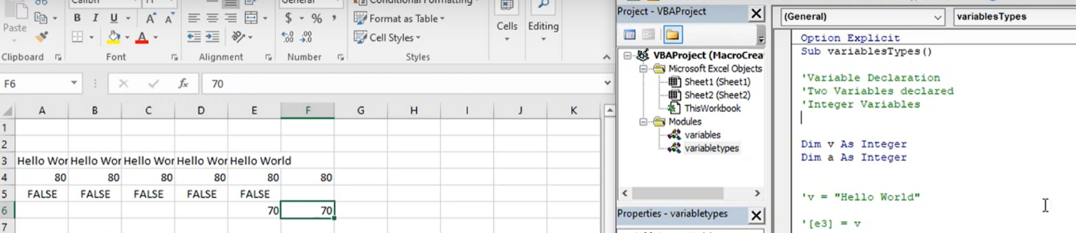

7. How do you add comments in a VBA code? How do you add multiple
lines of comments in a VBA code?
Multiple line comments:
Add an apostrophe at the start of each line.
Example:
' Line 1 of the comment
' Line 2 of the comment
' Line 3 of the comment
Alternatively, select multiple lines and press Ctrl + Shift + C to comment them. Use Ctrl + Shift + U to uncomment.


